**Project Report Template**

**TITLE: Recuruiting Assistant for the HR Managers**

**1. INTRODUCTION**

* 1. **Overview:**

The Project for recruiting Assistant for HR Manager aim to develop a software tool to assist HR managers in the recruitment process . The software tool will provide an automated platform to create job posting, monitor applicant resumes, schedule interviews, and even make suggestions based on the job requirements . The project will focus on creating an intuitive user interface, using data analytics tools, and developing a database system to store job posting, resumes and other relevant information. The goal is to save time and streamline the recruitment process for HR professionals , enabling them to Focus on other critical tasks.

* 1. **Purpose:**

They assist with recruitment and record maintenance for payroll processing as

well as provide clercial support to all employees

**2. Problem Definition & Design Thinking**

**2.1 Empathy Map**

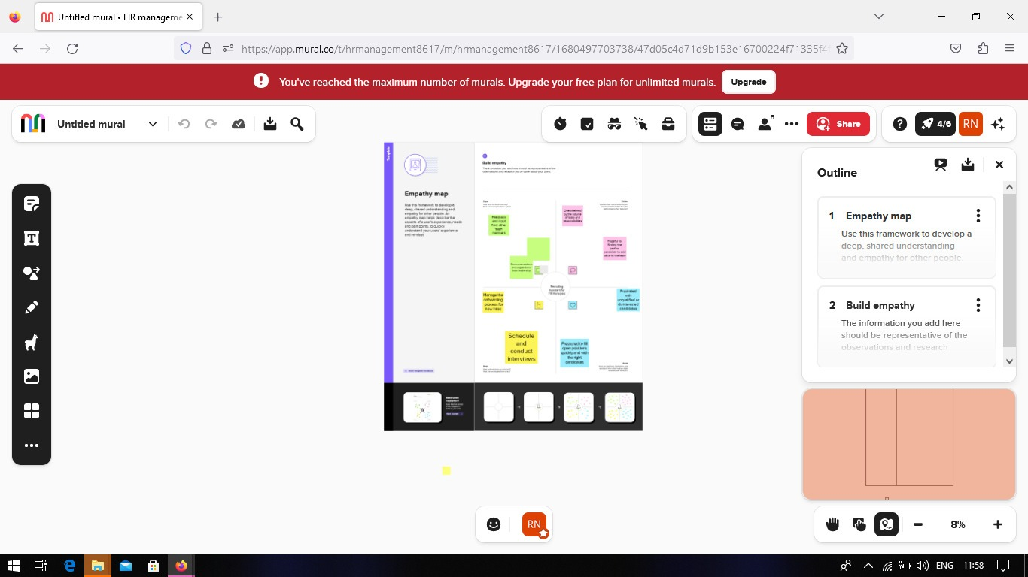

**2.2 Ideation & Brainstorming Map**

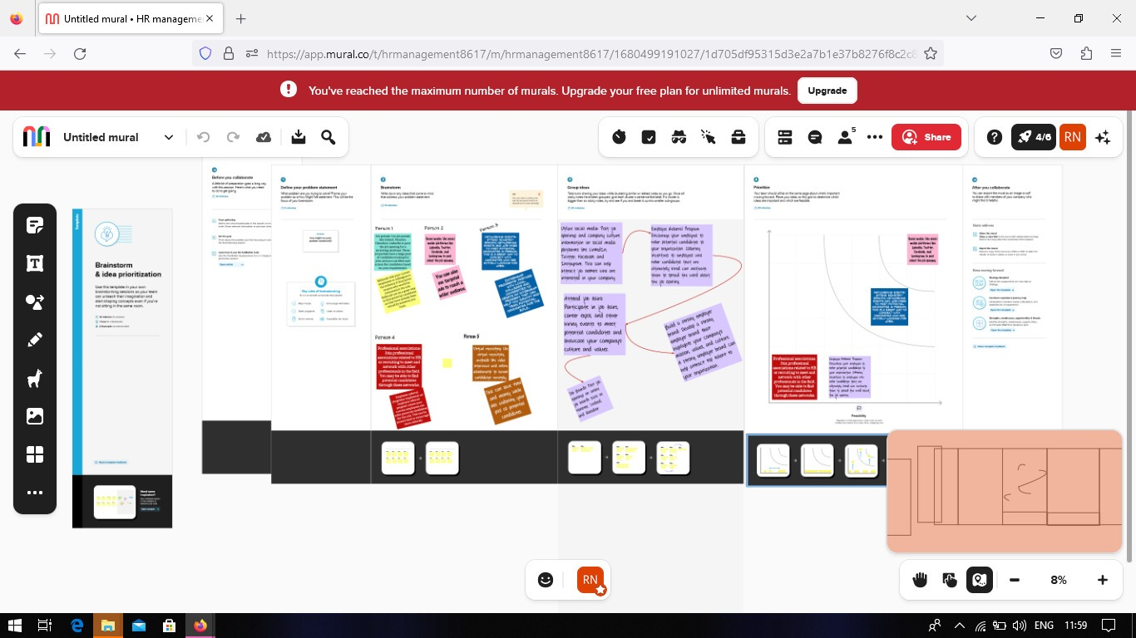

**3. RESULT**

**3.1 Data Model**:

|  |  |
| --- | --- |
| Object Name | Field in the Object |
| Obj - 1 | |  |  | | --- | --- | | Field Label | Data Type | | Job posting site | Text | |  |  | |
| Obj - 2 | |  |  | | --- | --- | | Field Label | Data Type | | Review | Auto number | | Job posting | Text | |

**Milestone 2 : Package installation**

**Package installation for Recruiting App**

In Salesforce, a package is a collection of Apex classes, triggers, Visualforce pages, and other components that can be installed into an organization. There are two types of packages: managed,. and unmanaged. Managed packages are developed and distributed by ISVs (Independent Software Vendors) and can be installed from the Salesforce AppExchange, while unmanaged packages are created and distributed by Salesforce administrators within an organization. To install a package, an administrator can navigate to the AppExchange, find the desired package, and click the "Install" button. The administrator will then be prompted to log in to their

Salesforce organization and provide permission to install the package.

**Milestone 3: Object**

**What is an object?**

Salesforce objects are database tables that permit you to store data that is specific to an organization. It consists of fields (columns) and records (rows). Salesforce objects are of two types

● Standard Objects: Standard objects are the kind of objects that are provided by

salesforce.com such as users, contracts, reports, dashboards, etc.

● Custom Objects: Custom objects are those objects that are created by users. They supply information that is unique and essential to their organization. They are the heart of any application and provide a structure for sharing data.

Milestone 4 : Tabs

What is Tab?

In Salesforce, a tab is a user interface element that allows users to navigate to different sections of the platform, such as Accounts, Contacts, Leads, and Opportunities. Tabs can also be used to access custom objects and custom pages. They are typically located at the top of the screen and can be customized to fit the needs of the organization.

**Milestone 5 : Fields**

**What are fields?**

Fields in Salesforce represents what the columns represent in relational databases. It can store data values which are required for a particular object in a record.

There are 2 types of fields in salesforce:

● Standard fields: There are four standard fields in every custom object that are Created By, Last Modified By, Owner, and the field created at the time of the creation of an object. These fields cannot be deleted or edited and they are always required. For standard objects, the fields which are present by default in them and cannot be deleted from standard objects are standard fields.

.

● Custom fields: The Custom fields which are added by the administrator/developer to meet the business requirements of any organization. They may or may not be required.

**3.2 Activity & Screenshot**

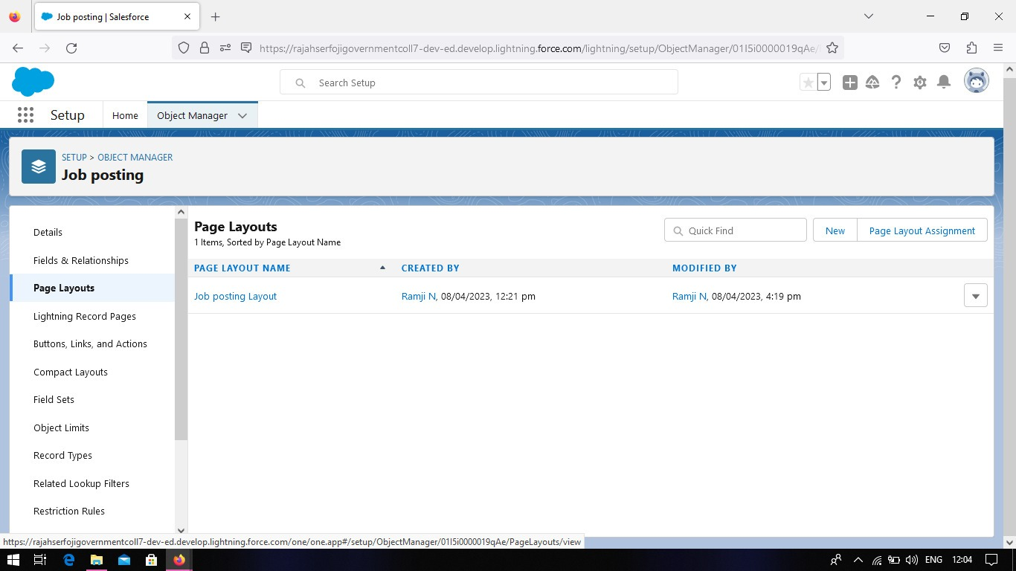

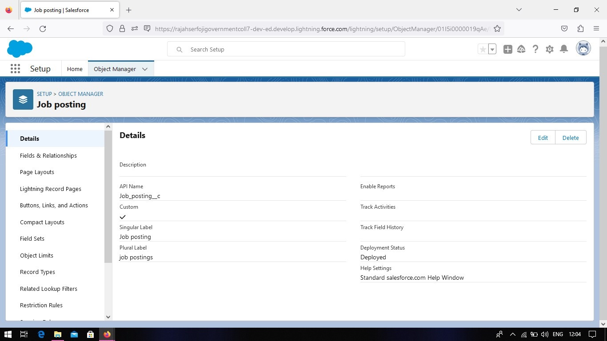

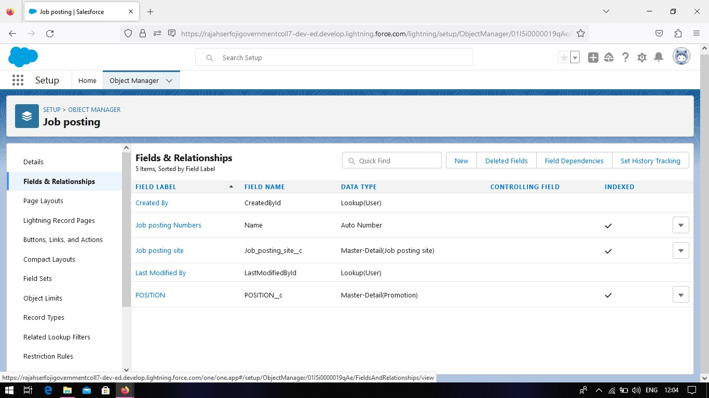

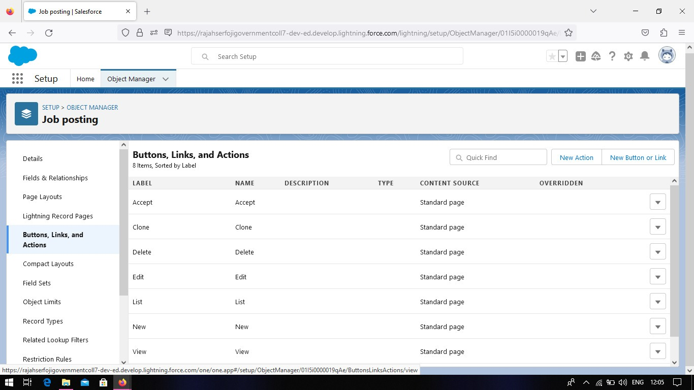

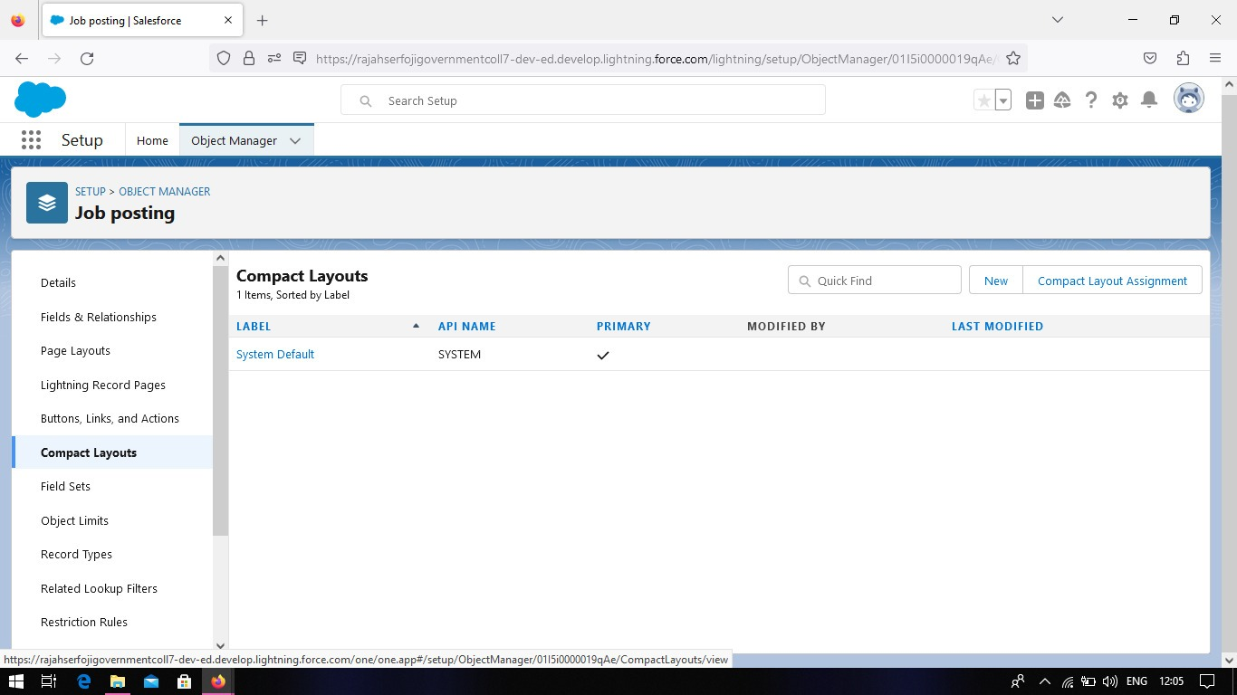

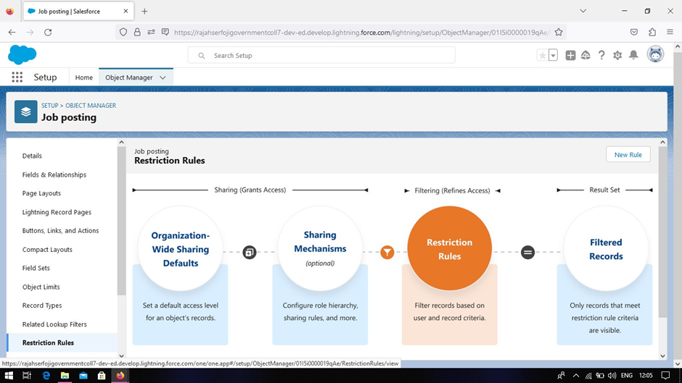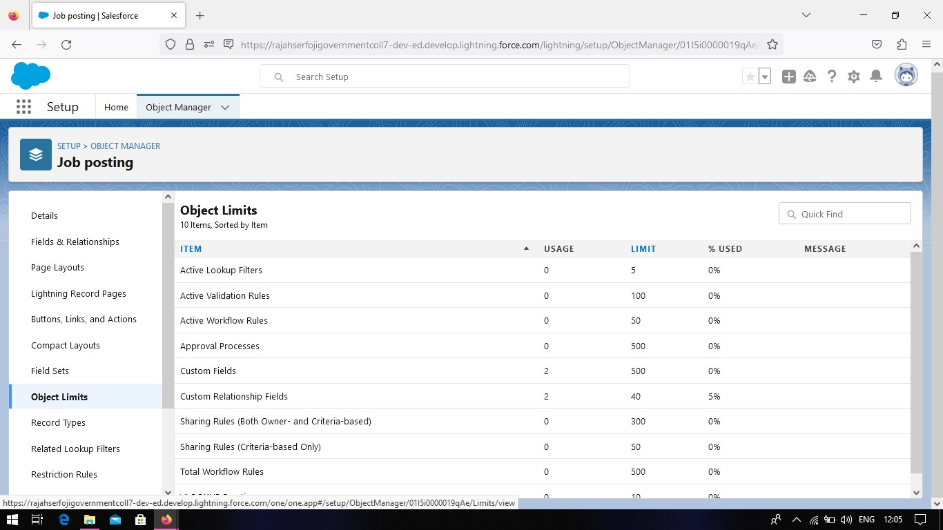

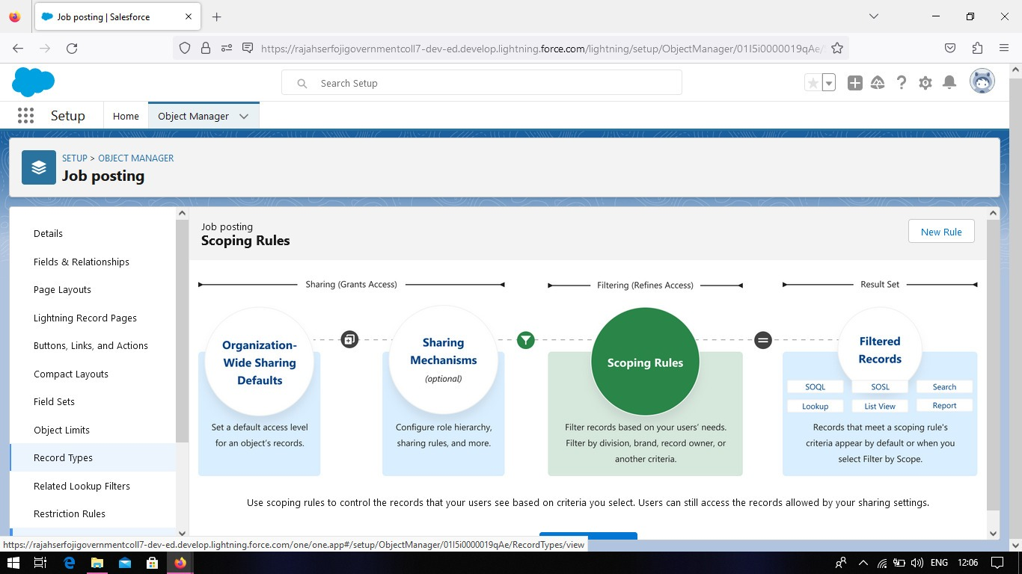

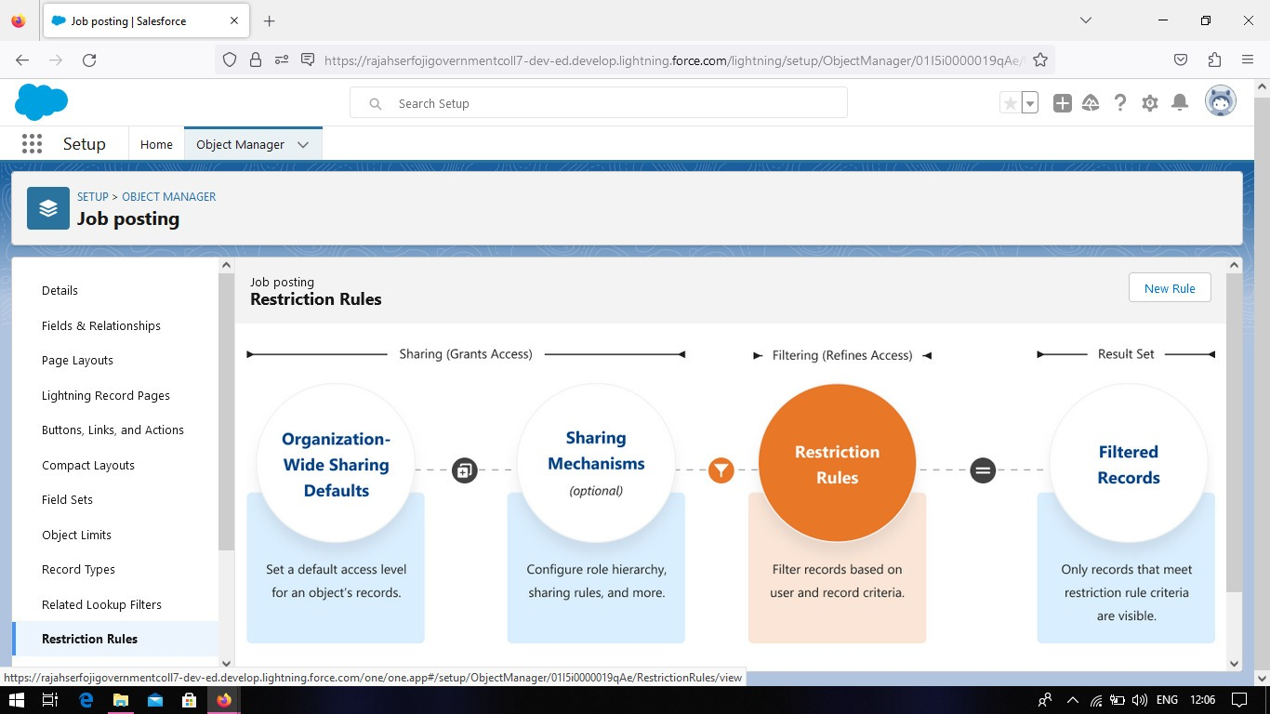

**4. Trailhead Profile Public URL**

Team Lead –N. Ramji- <https://trailblazer.me/id/ramjn1>

Team Member 1 -S.Sathiyamoorthi- <https://trailblazer.me/id/saths54>

Team Member 2 -VR.Lakshmanan- <https://trailblazer.me/id/vvrlakshmanan>

Team Member 4 –Sritharan- <https://trailblazer.me/id/kstory6>

Team Member 5 - **ROHITH J -**  <https://trailblazer.me/id/roh1>

**5. ADVANTAGES & DISADVANTAGE**

**Advantages:**

* Time-saving
* Cost-effective
* Improved candidate experience
* Increased efficiency
* Enhanced data management

**Disadvantages:**

* Potential loss of the personal touch in the hiring process
* The Potential for biases to be built into the system

**6. APPLICATIONS :**

The Recruiting Assistant for HR Managers project can be applied in various organisations and industries that engage in recruitment activities.

**7. CONCLUSIONS**:

In conclusion , a recruiting Assistant for HR managers can provide numerous benefits in terms of efficiency , speed , and consistency in the hiring process.

**8. FUTURE SCOPE:**

* Integration with AI
* Chatbot functionality
* Automated reference checks
* Analytics and reporting
* Intergrating with other HR techonogies

Ni